Assignment 4

* **Part 1 (10 points) Watch Video Lecture Segments**

**Done**

* **Part 2 (10 points) Evaluate the Relational and Logical expressions in Video Segment 9.8**

#include <stdio.h>

#include <stdlib.h>

main(){

int a = 5, b = 4, c = 3, d = 2;

printf("a = 5, b = 4, c = 3, d = 2\n\n");

if(a <= b + 1) {

printf("a <= b + 1 is True\n");

}

else{

printf("a <= b + 1 is False\n");

}

if(a < b && c > b) {

printf("a < b && c > b is True\n");

}

else{

printf("a < b && c > b is False\n");

}

if(a >= c || d >=5){

printf("a >= c || d >=5 is True\n");

}

else{

printf("a >= c || d >=5 is False\n");

}

if(!(a > b)){

printf("!(a > b) is True\n");

}

else {

printf("!(a > b) is False\n");

}

if( b >= a && !(d < b)){

printf("b >= a && !(d < b) is True\n");

}

else {

printf("b >= a && !(d < b) is False\n");

}

return 0;

}

**Results of practice:**

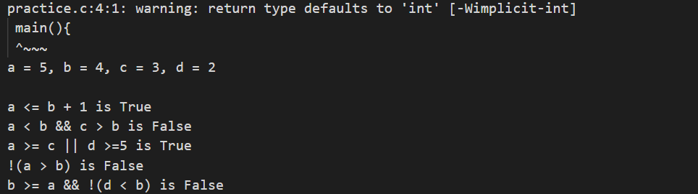

* **Part 3 (80 points) Write a C program (with meaningful comments) to solve a problem described in English. Create an IPO.**

1. **I = User Inputted Grade;**
2. **P = Inputted Grade++; PassingGradeCount / TotalGradeCount; Multiply final number by 100;**
3. **O = Final percentage of passing grades.**

**Test Case #1**

Grades Entered: Expected Results:

99

89

60

42

-123 This is not a valid grade

678 This is not a valid grade

65

100

-1 You entered 3 passing grades.

50% of the valid grades entered are passing grades.

**Test Case # 2**

Grades Entered: Expected Results:

42

-4 This is not a valid grade

154 This is not a valid grade

67

89

99

75

44

23

988 This is not a valid grade

-1 You entered 3 passing grades.

42.86% of the valid grades entered are passing grades.

#include <stdio.h>

#include <stdlib.h>

//Katherine Manning

//Feb 26, 2021

/*Create program that takes user input on grade

Only accept numbers 0-100. Use -1 to quit program

70 is min passing grade

present error if wrong number input

calc perc passing

*/

int main(void) {

//Declare vars

int input;

float passCount = 0;

float totalCount = 0;

int countedGrades;

float percentTotal;

float finalTotal;

//Begin Sentinel loop for grades

while (input != -1)

{

printf("Please input grade (-1 to end program):");

scanf ("%i", &input);

//Post error if any number over 100 and under -1 is inputted

if (input >= 101){

printf("That is not a valid grade.\n");

}

if(input <= -2){

printf("That is not a valid grade.\n");

}

//Only include grades between 69 and 100 (Grades over 70 are passing)

if(input > 69 && input < 101){

//Count how many inputted passing grades and total

passCount++;

//passCountforFinal++;

totalCount++;

//Testing that count is working

//printf("Testing pass count : %lf\n", passCount);

}

if(input <= 69 && input >=0){

//Make sure count includes non passing grades also

totalCount++;

//printf("Total Count: %lf\n", totalCount);

}

}

//Output passing avg of total grades

percentTotal = passCount / totalCount;

//Testing that percentTotal is correct

//printf("percentTotal output: %lf\n", percentTotal);

//Get percentage of passing grades

finalTotal = percentTotal * 100;

printf("-----------------------------------------\n");

printf("\nYou entered %.2lf passing grades.\n", passCount);

printf("-----------------------------------------\n");

printf("\nPercentage passing is: %.2lf\n", finalTotal);

printf("-----------------------------------------\n");

system("pause");

}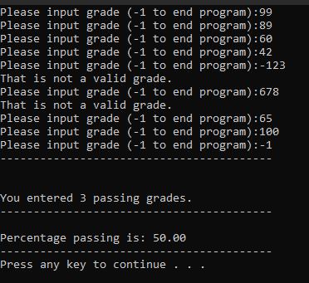

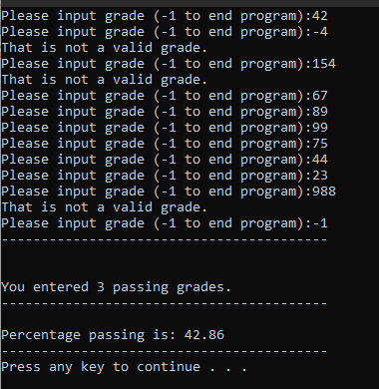

Final Count (Homework Assigned numbers to input)

